Topics:
- Software project management
- Management activities
- Project planningx
- Activity organizationx
- Milestones in the requirement process
- Project schedulingx
- Activity networks
- Risk management
- The Risk Management process Stages
- Risk Identification
- Risk Analysis @ @
- Risk Planningx
- Risk management strategies
- Risk monitoringx
- Risk indicatorsx

- Software project management
- Software project management ensures that software is delivered on time and meets the required specifications.

- Managing a project is essential because software development must adhere to budget and timeline constraints.

- Management activities
- Proposal Writing: Create a clear plan to get approval for a project.

- Project Planning & Scheduling: Organize tasks, set timelines, and assign resources.

- Project Costing: Estimate and manage the budget for the project.

- Project Monitoring & Reviews: Track progress and make adjustments as needed.

- Personnel Selection & Evaluation: Choose the right team and assess their performance.

- Report Writing & Presentations: Share updates and results with stakeholders.
- Project planningx
- Project planning is likely the most time-consuming part of managing a project.

- It is an ongoing process from the initial idea until the system is delivered. Plans need to be updated regularly as new information comes in.

- Different types of plans may be created to support the main project plan, which focuses on schedule and budget.

- Activity organizationx
- Project activities should be organized to produce clear outputs that help management assess progress.

- Milestones are the end-point of a process activity.

- Deliverables are project results delivered to customers.

- The waterfall process makes it easy to define progress milestones.
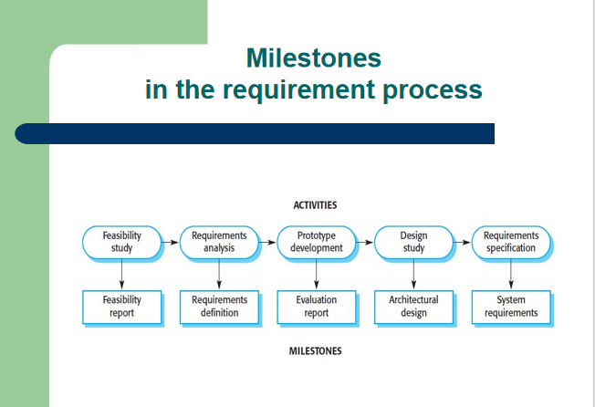
- Project schedulingx
- Break the project into tasks and estimate the time and resources needed for each task.

- Organize tasks concurrently to make optimal use of workforce.

- Reduce task dependencies to avoid delays caused by waiting for other tasks to finish.

- Dependent on project managers intuition and experience.

- Activity networks
Activity Networks are diagrams that show the flow and dependencies of tasks, including milestones, to help plan and manage the project schedule.Activity networks typically include:

Tasks/Activities: Individual tasks that need to be completed.

Dependencies: Relationships between tasks that determine the order in which they should be performed.

Milestones: Significant points or events in the project timeline.(Milestones are specific points in time that signify important achievements or stages.)

Critical Path: The longest sequence of dependent tasks that determines the minimum project duration.
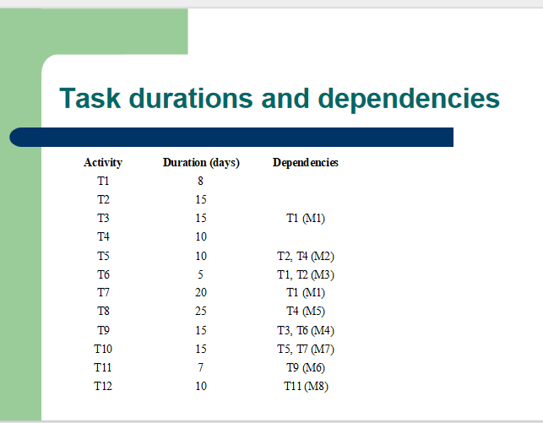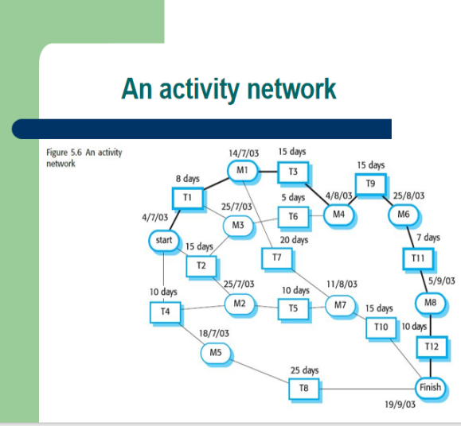

- Risk management
Risk management involves identifying risks and creating plans to reduce their impact on a project.

There are three main types of risks:
Project risks: Affect the project schedule or resources, like losing a key team member.

Product risks (quality risks): Affect the software's quality or performance, such as a purchased component not working as expected.

Business risks: Affect the organization, like a competitor launching a new product.

Risk | Risk type | Description
Staff turnover | Project | Experienced team members may leave before the project is finished.
Management change | Project | Organizational management may change, bringing different priorities.
Hardware unavailability | Project | Essential hardware might not be delivered on time.
Requirements change: | Project & product | There will be a larger number of changes to the requirements than anticipated.
Specification delays: | Project & product | Specifications of essential interfaces are not available on schedule.
Size underestimate | Project & product | The size of the system has been underestimated.
CASE tool under-performance | Product | CASE tools may not perform as expected.
Technology change | Business | The technology used for the system might become outdated.
Product competition | Business | A competitive product is marketed before the system is completed.

- The Risk Management process Stages

Risk identification: Identify project, product, and business risks.

Risk analysis: Assess how likely each risk is and what its impact could be.

Risk planning: Create plans to avoid or reduce the impact of risks.

- Risk monitoring: Continuously assess risks and update mitigation plans as more information becomes available.

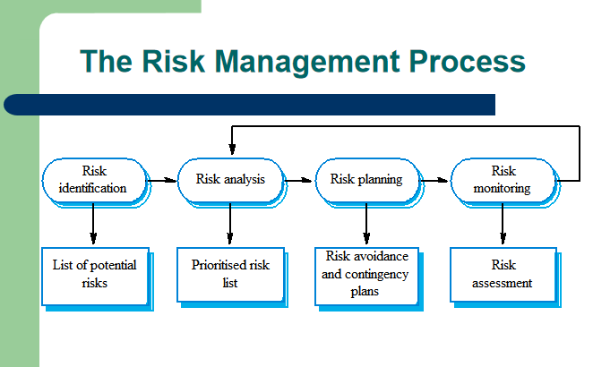

- Risk Identification: This is the initial step in risk management, focused on identifying potential risks to the project.

Methods: It can be done as a team activity using brainstorming or based on past experiences.

Types of Risks:

Technology Risks: Risks related to technology used in the project.

People Risks: Risks associated with the team or personnel.

Organisational Risks: Risks stemming from the organization's structure or processes.

Requirements Risks: Risks related to project requirements and specifications.

Estimation Risks: Risks arising from inaccurate project estimates.

X Don’t need this table X
Risk Type | Possible risks
Technology | Database may not handle expected transactions; reusable software components may have defects.
People | Difficulty in hiring skilled staff; key staff may be unavailable; required training may not be available.
Organisational | Management changes; budget cuts due to financial issues.
Tools | Inefficient code from CASE tools; integration issues with CASE tools.
Requirements | Major design changes due to requirement changes; customers may not understand the impact of changes.
Estimation | Underestimation of development time, defect repair rate, and software size.

- Risk Analysis: ( Don’t Know About It )
Assess the likelihood and impact of each risk.

Probability Levels: Very low, low, moderate, high, very high.

Impact Levels: Catastrophic, serious, tolerable, insignificant.

Risk | Probability | Impact
Budget cuts due to financial problems. | Low | Catastrophic
Unable to hire skilled staff. | High | Catastrophic
Key staff ill at critical times. | Moderate | Serious
Defects in reusable software components. | Moderate | Serious
Major design changes due to requirement shifts. | Moderate | Serious
Management changes due to restructuring. | High | Serious
Database can't handle expected transactions. | Moderate | Serious
Development time underestimated. | High | Serious
CASE tools can't be integrated. | High | Tolerable

- Risk Planning:x
Consider each risk and develop a strategy to manage that risk.
These strategies fall into three categories:
- Avoidance Strategies: Reduce the chance of the risk occurring (e.g., handling defective components).

- Minimisation Strategies: Reduce the impact of the risk (e.g., managing staff illness).

- Contingency Plans: Have plans ready if the risk occurs (e.g., dealing with financial problems).

- Risk management strategies
Risk | Strategy
Organisational Financial Problems: | Show management the project's importance.
Recruitment Problems: | Warn the customer, consider buying components.
Staff Illness: | Reorganize team, share tasks.
Defective Components: | Replace with reliable components.
Requirements Changes: | Understand impact, keep design simple.
Organisational Restructuring: | Show management the project's importance.
Database Performance: | Buy a better database.
Underestimated Development Time: | Buy components or use a program generator.

- Risk Monitoring: x
Regularly assess identified risks to see if they are becoming more or less likely.

Factors to Observe: Monitor specific factors that indicate changes in risk probability and impact, depending on the type of risk.

- Risk indicatorsx
Risk Type | Potential Indicators
Technology | Late hardware/software delivery, frequent tech issues
People | Low morale, poor team relationships, job availability
Organisational | Gossip, lack of senior management action
Tools | Team reluctance to use tools, complaints about CASE tools, demands for better workstations
Requirements | Many change requests, customer complaints
Estimation | Missed schedules, unresolved defects

